Dear students:

Assalm o alikum

On behalf of virtual university I welcome u all to the course of data communication in 4th smester.

My name is asim khan and I am going to be your instructor for this specific course.

Before we can actually move on with the discussion of the course I just want to briefly introduce myself.

As I have already told u my name is asim khan and I have done my mcs from bzu university multan pakistan

The course is intended for those who have a little or no knowledge for data com..

Data communication is different from telecoomunication telecommunication com is exchange of informationn between two parties replaced for apart.

Data com is subset of tele com.

Data communication is the exchange of information(in form of 0,s and 1,s) between two devices(comuters) using a transmission medium.

1837 telegraph

1876 alexander garaham bel telephone

1970 people started thinking judst voice is not enough video and pics oe files should be transmitted.

Effectiveness depends on three factors:

* Delivery
* Accuracy
* Timeliness (better never than late)

Data com system is made of 5 components:

* Message(data which is communicated in form,text,video etc in form of 0,s ,1,s)
* Sender
* Receiver
* Medium (physical path that a message takes in order to reach from sender to receiver )
* Protocol(set of rules that governs communication. Act as agreement between devices.).

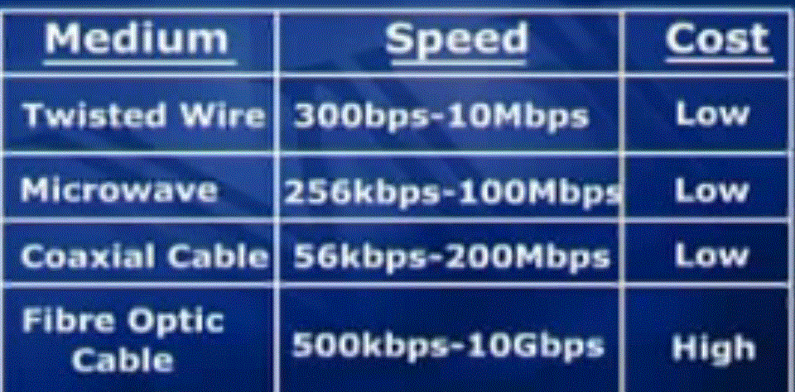

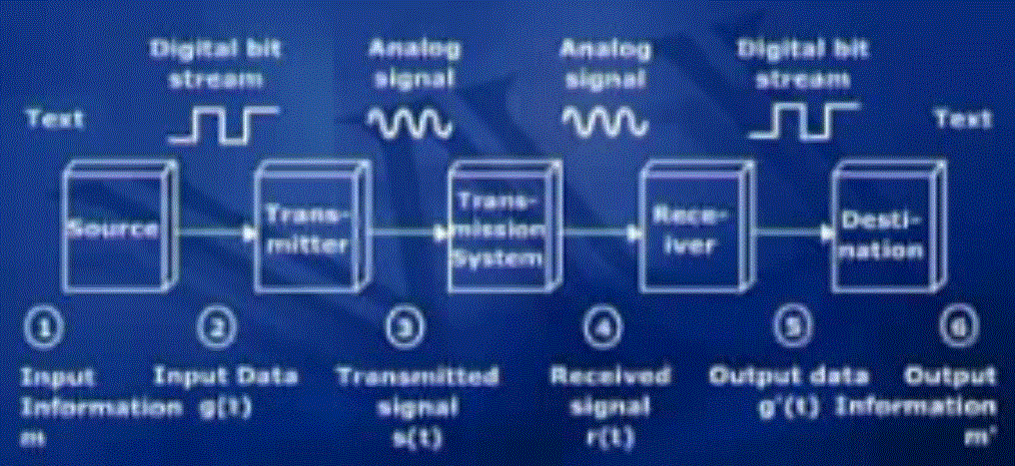

I hope u have enjoyed the first lecture and u understood almost every thing that we discuss in 1st lecture. I hope u complete the task which was assigned u in previous lecture.

Phone example of session:

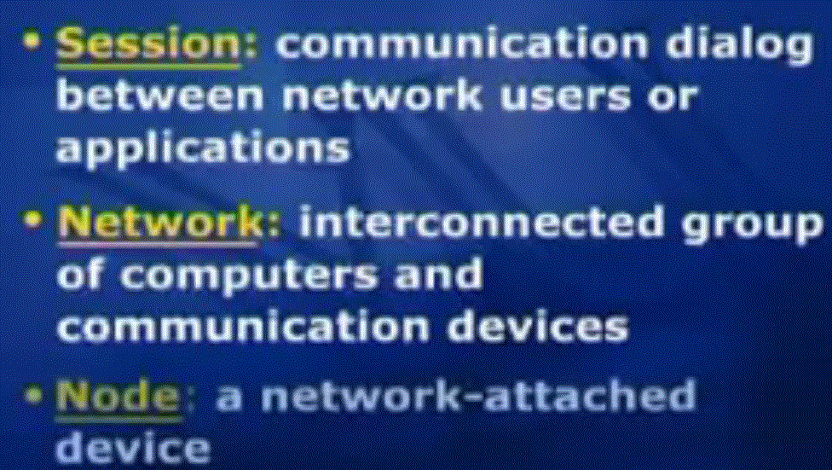

A node can be computer,priter or any device connected to network

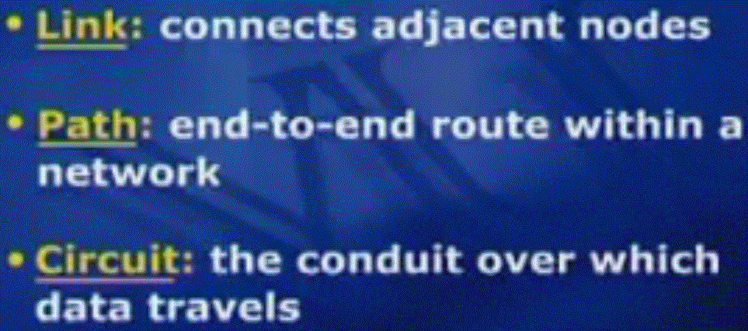

Link can be physical path (fiber optic cable).

